VIETNAM GENERAL CONFEDERATION OF LABOR

**TON DUC THANG UNIVERSITY**

**FACULTY OF ELECTRICAL & ELECTRONICS ENGINEERING**



**NGUYEN DUC TRI**

**SMART SWEEPING ROBOT**

**EMBEDDED SYSTEMS PROJECT**

**ELECTRONIC AND TELECOMMUNICATIONS ENGINEERING**

**HO CHI MINH CITY, MAY 2023**

VIETNAM GENERAL CONFEDERATION OF LABOR

**TON DUC THANG UNIVERSITY**

**FACULTY OF ELECTRICAL & ELECTRONICS ENGINEERING**



**Nguyen Duc Tri - 41900297**

**SMART SWEEPING ROBOT**

**EMBEDDED SYSTEMS PROJECT**

**ELECTRONIC AND TELECOMMUNICATIONS ENGINEERING**

*Lecturer:* **TS. Nguyen Kieu Tam**

*Student:* **Nguyen Duc Tri**

*MSSV:* **41900297**

*CLASS:* **19H40201**

**HO CHI MINH CITY, MAY 2023**

**ACKNOWLEDGMENT**

First of all, I would like to thank our teacher – Dr. Nguyen Kieu Tam has been dedicated in helping me as well as creating favorable conditions for me to complete this project. This is a very practical and necessary project for me, this knowledge will be my luggage for my next projects. In the process of implementing the thesis, there are still many mistakes, hope to receive comments from the teacher. Once again, I sincerely thank we!

*Ho Chi Minh City, May 07th, 2023*

*Author*

*(Signature and full na me)*

*Nguyen Duc Tri*

The work was completed at Ton Duc Thang University

Scientific instructors: Dr. Nguyen Kieu Tam

The specialized project was defended at the **Specialized Project Evaluation Council of Ton Duc Thang University** on … /…/20

Confirmation of the Chairman of the Evaluation Council of the Specialized Project and the Dean of the Faculty of Specialized Management after receiving the corrected Specialized Project (if any).

*LECTURER*

*(Signature and full name)*

...…………………...........

**DECLARATION OF AUTHORSHIP**

I hereby declare that this is my own specialized project and is under the scientific guidance of **Dr. Nguyen Kieu Tam**. The research contents and results in this topic are honest and have not been published in any form before. The data in the tables for analysis, comments and evaluation are collected by the author himself from different sources, clearly stated in the reference section.

In addition, in the Specialized Project, a number of comments, assessments as well as data from other authors, other agencies and organizations are used, all with citations and source annotations.

**If detect any fraud, I would like to take full responsibility for the content of my Embedded systems Project**. Ton Duc Thang University is not related to copyright and copyright violations caused by me during the implementation process (if any).

*Ho Chi Minh City, May 07th, 2023*

*Author*

*(Signature and full name)*

*Nguyen Duc Tri*



| TON DUC THANG UNIVERSITY **FACULTY OF ELECTRICAL AND ELECTRONICS ENGINEERING** | SOCIALIST REPUBLIC OF VIETNAM  Independence - Freedom – Happiness  ---------------------- |
| --- | --- |

**PROCESS OF EMBEDDED PROJECT**

Name of student: Nguyen Duc Tri

Class: 19H40201 Student ID:41900297 Advisor: Dr. Nguyen Kieu Tam

Subject name: Smart sweeping robot.

|  |  |  |  |
| --- | --- | --- | --- |
| **Week/Day** | **List of works** | | **ADVISOR**  **confirm** |
| **Done** | **Continue** |
| **1**  **(27/2 – 5/3)** | * Get the project task sheet. * Choose a topic and fill in the task sheet. * Understand the requirements of the subject content. | * Research on project topics. |  |
| **2**  **(6/3 – 12/3)** | * Study about the project topic components. | * Study the project topic components. |  |
| **3**  **(13/3–19/3)** | * Study components and draw schematic diagram, block diagram. | * Study and draw algorithm diagram. |  |
| **4**  **(20/3–26/3)** | * Study about threshold values of the components in the circuit | * Study about threshold values of the components in the circuit |  |
| **5**  **(27/3–2/4)** | * Research and study code of Arduino IDE software | * Programming communication and simulation on Proteus software |  |
| **6**  **(3/4–9/4)** | * Programming communication and simulation on Proteus software | * Find and order components to make hardware |  |
| **7**  **(10/4–16/4)** | * Conduct model assembly and test run | * Conduct model assembly and test run |  |
| Mid-term test | The instructor evaluates the completed volume %  Continue Discontinue | | |
| **8**  **(17/4–23/4)** | * Order the components to remake the robot model | * Order the components to remake the robot model |  |
| **9**  **(24/4–30/4)** | * Remake the robot model | * Remake the robot model |  |
| **10**  **(1/5–7/5)** | * Check the model again as well as make the complete project report file | * Check the model again as well as make the complete project report file |  |
| Submit embedded  project | Accomplished % Embedded project  Defend/undefend embedded project | | |

**TABLE OF CONTENTS**

🕮 OVERVIEW 🕮

**I.** **INTRODUCTION OF THE PROJECT** 13

**a.** **The reason for writing** 13

**b.** **The reality** 13

**c.** **The purpose** 14

**d.** **The methods** 14

**i.** **Research subjects** 14

**ii.** **Research scope** 14

**iii.** **Manufacturing Research Methods** 14

**II.** **THEORY** 15

**a.** **Overview about automatic vacuuming robot** 15

**i.** **Concept** 15

**ii.** **Mission** 15

**iii.** **Classify** 15

**b.** **Operating principle** 15

**i.** **Working Statuses** 15

**ii.** **Working Principle** 16

🕮 PREPARATION & IMPLEMENTATION 🕮

**I.** **SOME COMPONENTS USED IN THE PROJECT** 17

**a.** **Arduino Uno R3** 17

**b.** **Module HC-SR04** 19

**c.** **Module L298N** 20

**d.** **Module DC LM2596 3A** 21

**e.** **Module DC PWM 5A, 3-35V** 22

**f.** **Module RC Servo** 23

**g.** **Module LM393** 24

**h.** **Module ESC 30A** 24

**i.** **Motor Nidec BLDC** 25

**j.** **Pin Lipo 2S 2200mAh** 26

**II.** **IMPLEMENTATION** 27

**a.** **Design ideas** 27

**b.** **Block Diagram** 27

**i.** **Source block** 27

**ii.** **Processing block** 28

**iii.** **Sensor block** 31

**iv.** **Executive block** 33

**c.** **Test ARDUINO UNO R3** 35

**d.** **Test module HC-SR04** 39

**e.** **Test module LM393** 42

🕮 DESIGN & CODING 🕮

**I.** **DESIGN** 45

**a.** **Alternative diagram** 45

**b.** **Circuit assembly diagram** 46

**II.** **CODING** 47

**III.** **SUPPLIES AND COMPONENTS** 51

🕮 TESTING AND EVALUATION 🕮

🕮 REFERENT 🕮

🕮 APPENDIX A. PROGRAMMING CODE 🕮

**LIST OF FIGURES**

***FIGURE 1*. ARDUINO UNO R3** 18

***FIGURE 2*. ARDUINO UNO R3 CHIP CH340G** 19

***FIGURE 3*. ULTRASONIC SENSOR HC-SR04** 20

***FIGURE 4*. ENGINE CONTROL MODULE L298N** 21

***FIGURE 5*. DC PRESSURE REDUCING CIRCUIT LM2596 3A** 22

***FIGURE 6*. MOTOR DRIVER CIRCUIT DC 5A** 23

***FIGURE 7*. RC-SERVO MOTOR TEST CIRCUIT** 23

***FIGURE 8*. INFRARED OBSTACLE SENSOR MODULE LM393** 24

***FIGURE 9*. BRUSHLESS MOTOR SPEED CONTROL CIRCUIT 30A** 25

***FIGURE 10*. MOTOR NIDEC VACUUM CLEANER BLDC** 25

***FIGURE 11*. PIN LIPO 2S 2200MAH** 26

***FIGURE 12*. BLOCK DIAGRAM** 27

***FIGURE 13*. ARDUINO UNO R3 CHIP CH340G (in detail)** 28

***FIGURE 14*. ARDUINO POWER PINS** 29

***FIGURE 15*. ARDUINO PORTS** 30

***FIGURE 16*. ULTRASONIC SENSOR PORTS** 31

***FIGURE 17*. INFRARED SENSOR LM393 (IR SENSOR MODULE) PORTS** 32

***FIGURE 18*. YELLOW GEAR MOTOR** 33

***FIGURE 19*. YELLOW GEAR MOTOR** 34

***FIGURE 20*. RC SERVO MOTOR TEST CIRCUIT** 34

***FIGURE 21*. PLUG THE CIRCUIT BOARD INTO THE COMPUTER** 35

***FIGURE 22*. THE SAMPLE CODE “BLINK” IN ARDUINO IDE** 36

***FIGURE 23*. THE SAMPLE CODE “BLINK” CONNECT WITH ARDUINO PORT** 37

***FIGURE 24*. THE LED LIGHT OF ARDUINO BOARD IS TURN ON WHEN YOU UPLOAD THE CODE TO THE BOARD** 38

***FIGURE 25*. THE TEST CODE OF ULTRASONIC SENSOR** 39

***FIGURE 26*. CONNECT THE ULTRASONIC SENSOR TO A ARDUINO BOARD** 40

***FIGURE 27*. UPLOAD CODE TO ARDUINO BOARD** 41

***FIGURE 28*. ULTRASOUND SENSOR MEASURES THE RANGE TO OBJECTIVES AND DISPLAYS ON SERIAL MONITOR OF ARDUINO IDE SOFTWARE** 41

***FIGURE 29*. THE TEST CODE OF INFRARED SENSOR LM393** 42

***FIGURE 30*. PLUG THE IR SENSOR TO ARDUINO BOARD** 42

***FIGURE 31*. UPLOAD TEST CODE OF IR SENSOR TO ARDUINO SOFTWARE** 43

***FIGURE 32*. IR SENSOR MEASURES THE RANGE TO OBJECTIVES AND DISPLAYS ON SERIAL MONITOR OF ARDUINO IDE SOFTWARE** 44

***FIGURE 33*. ALGORITHM DIAGRAM** 45

***FIGURE 34*. USING PROTEUS SOFTWARE TO SIMULATION** 46

***FIGURE 35.* SMART SWEEPING ROBOT CODE (1)** 47

***FIGURE 36*. SMART SWEEPING ROBOT CODE (2)** 48

***FIGURE 37*. SMART SWEEPING ROBOT CODE (3)** 48

***FIGURE 38*. SMART SWEEPING ROBOT CODE (4)** 49

***FIGURE 39*. SMART SWEEPING ROBOT CODE (5)** 49

***FIGURE 40*. SMART SWEEPING ROBOT CODE (6)** 50

**OVERVIEW**

1. **INTRODUCTION OF THE PROJECT**
   1. **The reason for writing**

Robots have become an integral part of our daily lives, and their uses are increasing day by day. They are designed to perform tasks that are either dangerous or impossible for humans to do. The use of robots has revolutionized the way we live, work, and interact with each other.

One of the most significant uses of robots is in manufacturing industries. Robots can work tirelessly without getting tired or making mistakes, which increases productivity and efficiency. They can also perform tasks that require precision and accuracy, such as assembling small parts or welding.

Robots are also used in healthcare to assist doctors and nurses in surgeries and other medical procedures. They can be programmed to perform repetitive tasks such as taking vitals or administering medication, freeing up healthcare professionals' time to focus on more critical aspects of patient care.

In addition to these practical applications, robots are also used for entertainment purposes such as in movies or amusement parks. They provide a unique experience for people while showcasing their capabilities.

Overall, the use of robots has made our lives easier and safer while opening up new possibilities for innovation and creativity. As technology continues to advance, we can expect even more exciting uses for robots in the future. For these ideals, I have chosen this topic to make a vacuum cleaner robot.

* 1. **The reality**

Robot vacuum cleaner is a type of robot that moves automatically without human control, it will automatically avoid obstacles and it can vacuum all places in the house.

In fact, there are many robot vacuum cleaners that have been produced using logic circuit technology, which has been applied very early and aimed certain achievements. At the same time, there are also some disadvantages such as the robot's difficulty in identifying obstacles and moving to avoid them accurately. To overcome this shortcoming, the project has built and designed a robot vacuum cleaner while avoiding obstacles by the signal from the ultrasonic sensor and infrared sensor.

In the project using the Arduino Uno R3 microcontroller module, this is a very common and very easy to program moudule. In addition, the vacuum cleaner uses available materials that are easy to find on the market and very easy to fabricate and assemble..

* 1. **The purpose**

Complete design and process to make an automatic robot vacuum cleaner capable of avoiding indoor obstacles and vacuuming.

* 1. **The methods**

The project has approached the results of a number of published robot manufacturing projects such as: robot manufacturing theory, database and operating principles of some electronic components, a number of specialized meters, programming and simulation software.

* + 1. **Research subjects**
* Robot avoids obstacles
* Robot vacuum cleaner
* System of distance sensors
* How to communicate between Arduino UNO R3 with sensor system and motor control module
  + 1. **Research scope**

Research and design an automatic vacuum cleaner capable of vacuuming and automatically avoiding obstacles for indoor

* + 1. **Manufacturing Research Methods**
* Expert method: Ask for expert's opinion in the field of research
* Theoretical research method: Researching documents related to the topic
* Practical research methods:
  + Simulation on proteus and arduino software
  + Use available modules optimally and reasonably
  + Making robot body according to mechanical processing method
  + Method of writing code using arduino available software

1. **THEORY**
   1. **Overview about automatic vacuuming robot**
      1. **Concept**

An automatic vacuum cleaner is a robot that can move and vacuum automatically without a human operator - it can automatically avoid obstacles and vacuum. Automatic robot vacuum cleaner includes: microcontroller, motor control module, motor, sensor and vacuum cleaner part.

* + 1. **Mission**

The robot vacuum automatically avoids obstacles in the house from which it can move around the house to vacuum.

* + 1. **Classify**
* Classification of automatic vacuum cleaner robots based on the working principle of the sensor head has:
  + Robot avoids obstacles using infrared sensors: robots work based on the working principle of infrared sensors. The robot mainly detects obstacles using infrared waves.
  + Robot avoids obstacles using ultrasonic sensors: robots work based on the working principle of ultrasonic sensors. This robot mainly detects obstacles using ultrasonic waves.
  + Robot avoids obstacles using laser sensors: robots work based on the working principle of laser sensors. This robot mainly detects obstacles using lasers.
  + Robot avoids obstacles using many types of sensors: is a working system based on the principle of many types of sensors such as infrared sensors and ultrasonic sensors, ultrasonic sensors and laser sensors,... This robot mainly detects obstacles in different environments.
* Classification of automatic robot vacuum cleaners according to the part that performs the movement: works well in most human-made terrain. Steering wheel movement is simple and almost always ensures stability.
  1. **Operating principle**
     1. **Working Statuses**
* Standing state (when there is no obstacle): The robot will give a safe distance and the ultrasonic sensor will start measuring the distance.
* Movement state: The robot will always go straight until it encounters an obstacle.
* Obstacle state: The robot will measure the distance in front and the two sides from there to determine the reasonable direction of movement.
  + 1. **Working Principle**

Normally the robot works in the standing mode. In this mode, the robot always has a signal to check the work to the devices in the robot such as sensors, modules, etc., from which these sensors as well as these modules also have a response signal to the center.

When there are obstacles (walls, tables, chairs, ..) will affect the sensor. When these factors reach the working threshold, a signal will be generated to the center. At the control center, the signal processing activities take place. At the same time, the control center will control the motor module to make the robot change its motion.

**PREPARATION & IMPLEMENTATION**

1. **SOME COMPONENTS USED IN THE PROJECT**
   1. **Arduino Uno R3**

Arduino Uno R3 has 2 kind:

* Arduino Uno R3 Chip Atmega328P
* Arduino Uno R3 Chip CH340G

Specifications of *Arduino Uno R3 Chip Atmega328P*:

|  |  |
| --- | --- |
| Microcontroller | ATmega328 |
| Operating voltage | 5 V |
| Operating frequency | 16 MHz |
| Current Consumption | 30 mA |
| Input voltage (recommended) | 7-12 V |
| Input voltage (limit) | 6-20 V |
| Digital I/O pin | 14 (With 6 PWM output pins) |
| Analog input pins | 6 |
| Maximum current per I/O pin | 30 mA |
| Maximum output current (5V) | 500 mA |
| Maximum Output Current (3.3V) | 50 mA |
| Flash Memory | 32 KB (ATmega328) with 0.5KB used by  Bootloader |
| SRAM | 2 KB (ATmega328) |
| EEPROM | 1 KB (ATmega328) |

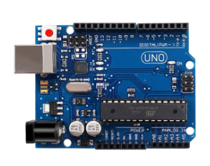

# **FIGURE 1. ARDUINO UNO R3**

Specifications of *Arduino Uno R3 Chip CH340G*:

|  |  |
| --- | --- |
| Microcontroller | ATmega328 |
| Operating voltage | 5 V |
| Operating frequency | 16 MHz |
| Current Consumption | 30 mA |
| Input voltage (recommended) | 7-12 V |
| Input voltage (limit) | 6-20 V |
| Digital I/O pin | 14 (With 6 PWM output pins) |
| Analog input pins | 6 |
| Maximum current per I/O pin | 30 mA |
| Maximum output current (5V) | 500 mA |
| Maximum Output Current (3.3V) | 50 mA |
| Flash Memory | 32 KB (ATmega328) with 0.5KB used by  Bootloader |
| SRAM | 2 KB (ATmega328) |
| EEPROM | 1 KB (ATmega328) |

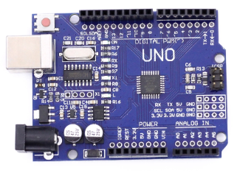

# **FIGURE 2. ARDUINO UNO R3 CHIP CH340G**

As can be seen in terms of specifications, nothing has changed, except for using the CH340G chip, so the Arduino Uno R3 chip CH340G has a much cheaper price.

In my project, I’m using the *Arduino Uno R3 chip CH340G.*

* 1. **Module HC-SR04**

Specifications of *Ultrasonic sensor HC-SR04*:

|  |  |
| --- | --- |
| Model | [HC-SR04](http://linhkientot.vn/wp-content/uploads/2016/02/ATmega328-328P_datasheet.pdf) |
| Operating voltage | 5 V |
| Current | 15 mA |
| Frequency | 40 kHz |
| Detection distance | 2 cm – 4 cm |
| Output signal | High level pulse 5V  Low level pulse 0V |
| Sensor angle | No more than 15 degrees |
| High precision | 3mm |
| Connection mode | VCC  Trig (T-Trigger)  Echo (R-Receive)  GND |

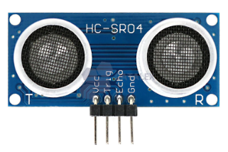

# **FIGURE 3. ULTRASONIC SENSOR HC-SR04**

* 1. **Module L298N**

Specifications of *Engine control module L298N | PWM | H-bridge circuit L298*:

|  |  |
| --- | --- |
| Driver | L298N integrated H bridge circuit |
| Control voltage | 5 – 12 V |
| Maximum current per bridge H | 2 A (=> 2A per motor) |
| Voltage of control signal | 5 – 7 V |
| Current of control signal | 0 – 36 mA |
| Wasted power | 20 W  (khi nhiệt độ T = 75⁰C) |
| Storage temperatures | -25⁰C – +130⁰C |

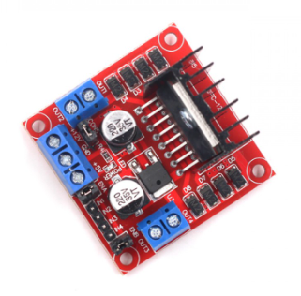

# **FIGURE 4. ENGINE CONTROL MODULE L298N**

* 1. **Module DC LM2596 3A**

Specifications of *DC Pressure Reducing Circuit LM2596 3A*:

|  |  |
| --- | --- |
| Input voltage | 3 – 30 V |
| Output voltage | 1.5 – 30 V |
| Maximum response current | 3 A |
| Efficiency | 92 % |
| Power | 15 W |

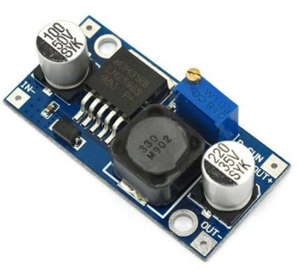

# **FIGURE 5. DC PRESSURE REDUCING CIRCUIT LM2596 3A**

* 1. **Module DC PWM 5A, 3-35V**

Specifications of *Motor driver circuit DC 5A*:

|  |  |
| --- | --- |
| Operating voltage | 5 – 35 V |
| Maximum output power | 90 W |
| Maximum output current | 5 A |
| Line break current | 0.015 A |
| PWM duty cycle | 1 – 100 % |
| PWM frequency | 10 kHz |

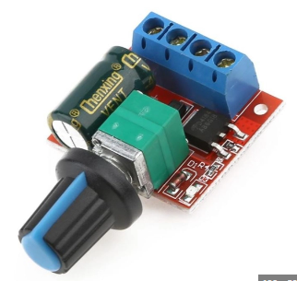

# **FIGURE 6. MOTOR DRIVER CIRCUIT DC 5A**

* 1. **Module RC Servo**

Specifications of *RC-Servo Motor Test Circuit*:

|  |  |
| --- | --- |
| Operating voltage | 4.5 – 6 V |
| Control frequency | 1.5 ms +/-0.5 ms |
| Maximum current | 15 mA |

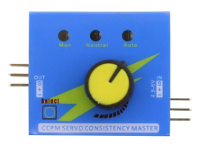

# **FIGURE 7. RC-SERVO MOTOR TEST CIRCUIT**

* 1. **Module LM393**

Specifications of *Infrared obstacle sensor module LM393:*

|  |  |
| --- | --- |
| Model | LM393 |
| Operating voltage | 3.3 – 5 V |

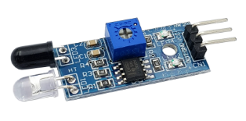

# **FIGURE 8. INFRARED OBSTACLE SENSOR MODULE LM393**

* 1. **Module ESC 30A**

Specifications of *Brushless motor speed control circuit 30A:*

|  |  |
| --- | --- |
| Voltage | 2-3S Lipo 4-12 NIMH |
| Continuous load current | 30 A |
| Instantaneous load current | 40 A |
| Type | Linear |
| BEC Output | 5V3A |

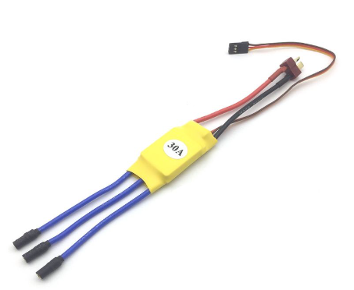

# **FIGURE 9. BRUSHLESS MOTOR SPEED CONTROL CIRCUIT 30A**

* 1. **Motor Nidec BLDC**

Specifications of *Motor Nidec vacuum cleaner BLDC:*

|  |  |
| --- | --- |
| Speed | 62 thousand rpm |
| Power | 360 W |

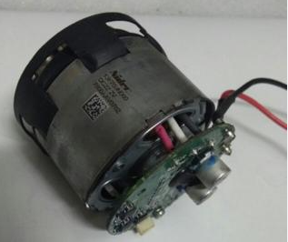

# **FIGURE 10. MOTOR NIDEC VACUUM CLEANER BLDC**

* 1. **Pin Lipo 2S 2200mAh**

Specifications of *Pin Lipo 2S 2200mAh:*

|  |  |
| --- | --- |
| Type | Lithium polymer |
| Power | 2200mah |
| Voltage | 7.4v/2s |
| Maximum discharge current | 25×2200/1000=55A |

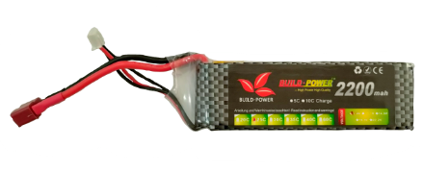

# **FIGURE 11. PIN LIPO 2S 2200MAH**

1. **IMPLEMENTATION**
   1. **Design ideas**

Automatic robot vacuum cleaner needs the following requirements:

* Detects obstacles and moves to dodge in a stable, flexible way.
* Compact design, easy to move through the nooks and crannies, easy to carry.
* No interference caused by other devices.
* Working with 12V voltage with motor.
* Vacuum cleaner, easy to clean.
  1. **Block Diagram**

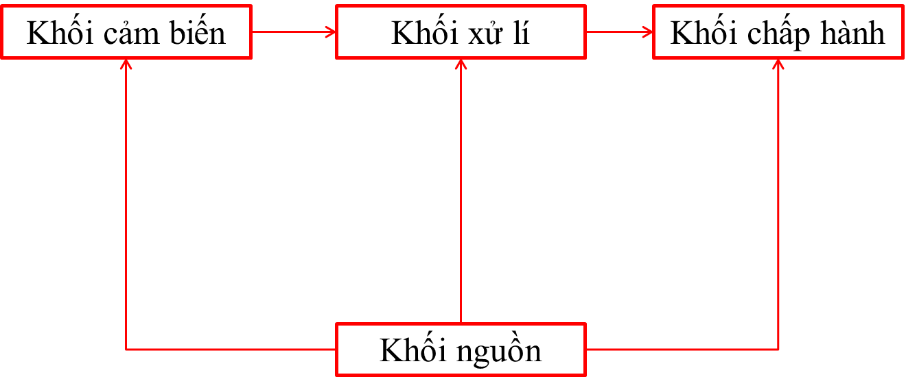

**SOURCE BLOCK**

**EXECUTIVE BLOCK**

**SENSOR BLOCK**

**PROCESSING BLOCK**

# **FIGURE 12. BLOCK DIAGRAM**

* + 1. **Source block**

Task: Using *PIN LIPO 2S 2200MAH* to provide power for electric circuits and motors.

*PROS*: Small, light and can be made in all shapes and sizes, high capacity, strong discharge current, stable battery power, long battery life,....

*CONS*: The price is quite high, the fire is low, but when it is on fire, it is very hot, and can explode when improperly charge or overcharge.

* + 1. **Processing block**

Task: Compare and process the received signals from the sensor block, thereby giving control signals to the actuator block.

Since in this project we use the Arduino Uno R3 chip CH340G, we will better understand its advantages and disadvantages, besides we will learn about the port pins of the arduino in detail.

*PROS*: Common in the market, easy to use, cheap price,...

*CONS*: It has a lot of built-in things so it will be difficult for beginners to learn to code.

Here is our chip:

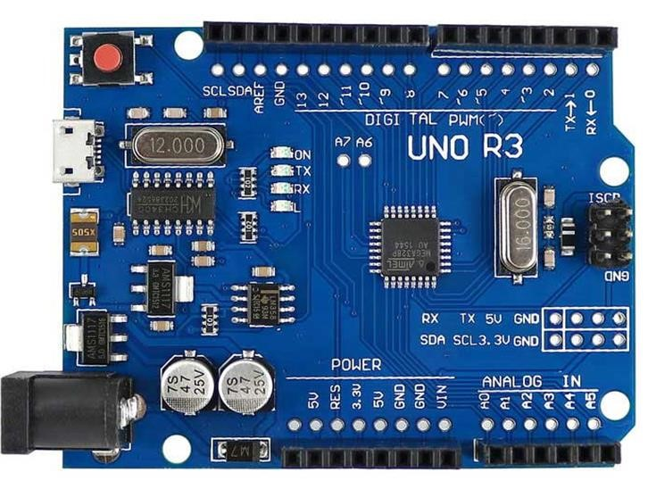

# **FIGURE 13. ARDUINO UNO R3 CHIP CH340G (in detail)**

Regarding the power to use, the Arduino UNO R3 can be powered by 5V through the USB port or powered externally with a recommended voltage of 7-12V DC or a limited voltage of 6-20V. If the power supply exceeds the upper limit threshold, it will damage the Arduino UNO.

About the power pins:

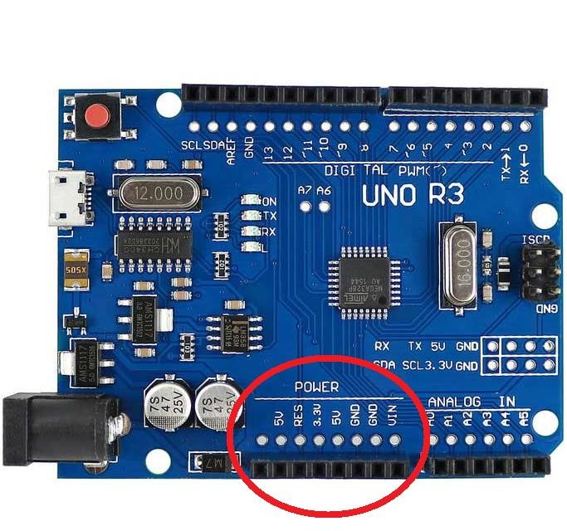

# **FIGURE 14. ARDUINO POWER PINS**

* *GND (Ground)*: negative pole of the power supply to the Arduino UNO. When you use devices that use separate power sources, these pins must be connected together.
* *5V*: 5V output voltage level. The maximum allowable current at this pin is 500mA.
* *3.3V*: 3.3V output voltage level. The maximum allowable current at this pin is 50mA.
* *Vin (Voltage Input)*: to supply external power to the Arduino UNO, you connect the positive pole of the source to this pin and the negative pole of the source to the GND pin.
* *IOREF*: the operating voltage of the microcontroller on the Arduino UNO can be measured at this pin.
* *RESET*: pressing the Reset button on the board to reset the microcontroller is equivalent to the RESET pin connected to GND through a 10KΩ resistor.

About memory usage:

* *32KB Flash memory*: the programming instructions will be stored in the microcontroller's Flash memory. Usually a few KB of this will be used for the bootloader.
* *2KB for SRAM (****S****tatic* ***R****andom* ***A****ccess* ***M****emory)*: the values of variables declared when programming will be stored here. The more variables you declare, the more RAM you need. When the power goes out, the data on the SRAM will be lost.
* *1KB for EEPROM (****E****lectrically* ***E****raseble* ***P****rogrammable* ***R****ead* ***O****nly* ***M****emory)*: A place where data can be read and written to without having to worry about losing power like data on SRAM.

About the ports:

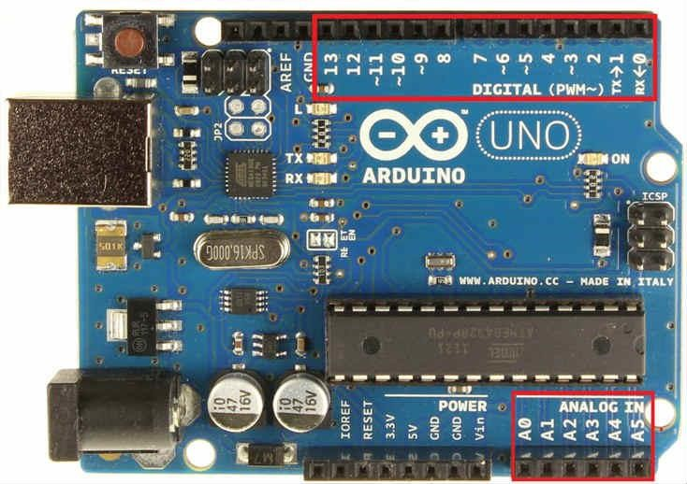

# **FIGURE 15. ARDUINO PORTS**

* *2 Serial pins*: 0 (RX) and 1 (TX): used to send (transmit - TX) and receive (receive - RX) TTL Serial data. Arduino Uno can communicate with other devices through these 2 pins. The most commonly seen bluetooth connection is simply a wireless Serial connection. If Serial communication is not required, you should not use these 2 pins unless necessary.
* *PWM pins (~)*: 3, 5, 6, 9, 10, and 11: allow you to output PWM pulses with 8bit resolution (values from 0 → 28-1 correspond to 0V → 5V) using the analogWrite function (). Simply put, you can adjust the output voltage at this pin from 0V to 5V instead of just being fixed at 0V and 5V like other pins.
* *SPI communication pins*: 10 (SS), 11 (MOSI), 12 (MISO), 13 (SCK). In addition to the usual functions, these 4 pins are also used to transmit data using the SPI protocol with other devices.
* *LED 13*: on Arduino UNO there is 1 orange led (signed L). When you press the Reset button, you will see this light blink to signal. It is connected to digital pin 13. When this pin is used by the user, the LED will light up.
* *Arduino UNO Broad has 6 analog pins (A0 → A5)* that provide 10bit signal resolution (0 → 210-1) to read voltage values in the range 0V → 5V. With the AREF pin on the board, you can input the reference voltage when using the analog pins. That is, if you apply a voltage of 2.5V to this pin, you can use the analog pins to measure the voltage in the range from 0V → 2.5V with a resolution of 10bit.
* In particular, the *Arduino UNO has 2 pins A4 (SDA) and A5 (SCL)* that support I2C/TWI communication with other devices.
  + 1. **Sensor block**

Task: Determine the distance from the obstacle to the robot and convert the signal to an electrical signal

Includes ultrasonic sensor HC-SR04 and infrared sensor LM393

About the *Ultrasonic sensor HC-SR04*:



# **FIGURE 16. ULTRASONIC SENSOR PORTS**

* Ports:
  + *VCC*: power to the sensor (5V) or 3.3V at the 3V3.
  + *TRIGGER*: Sound wave pin which is the cycle of high/low power taking place.
  + *ECHO*: Initial state is 0V, when return signal will be 5V and then return to 0V.
  + *GND*: Connect the negative terminal of the circuit
* Pros & Cons:
  + *PROS*: Less interference, determine the distance from the sensor to the obstacle, cheap price, popular in the market.
  + *CONS*: Small scanning angle

Formula for calculating distance:

$$L= \frac{V*t}{2}$$

*Where*: L -> Distance

V -> Speed of sound in air (V = 340m/s)

t -> Time

About the *Infrared sensor LM393*:

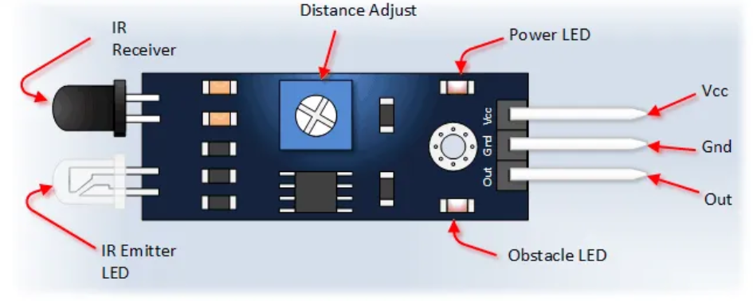

# **FIGURE 17. INFRARED SENSOR LM393 (IR SENSOR MODULE) PORTS**

* Ports:
  + *VCC*: voltage conversion from 3.3V to 5V (can be directly connected to 5V and 3.3V microcontrollers).
  + *GND*: Connect the negative terminal of the circuit.
  + *OUT*: digital output (0 & 1)
* Pros & Cons:
  + *PROS*: The infrared sensor has high sensitivity in identifying objects that emit infrared radiation in space. The sensor design allows to determine the exact distance of the object emitting infrared radiation. Simple design and structure, low cost.
  + *CONS*: Infrared sensors are highly dependent on ambient temperature conditions. In high temperature environments, the sensor will work less efficiently. Limited infrared sensor scanning angle and range, many dead angles. High sensitivity makes it easy to mistake when detecting motion.
    1. **Executive block**

Task: Help navigate the robot to avoid obstacles and control the motor of the brush and vacuum cleaner

Using yellow gear motor to control 2 wheels and 2 brushes

*PROS*: cheap and easy to use

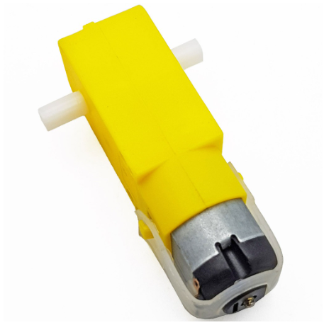

# **FIGURE 18. YELLOW GEAR MOTOR**

Using “Motor driver circuit DC 5A” to control the speed of sweeping motor, “RC-Servo Motor Test Circuit” to control the power of vacuum motor.

The *PROS* of these circuits are: Control the speed of the motor accurately and quickly, easy to use, affordable, the control principle is very easy.

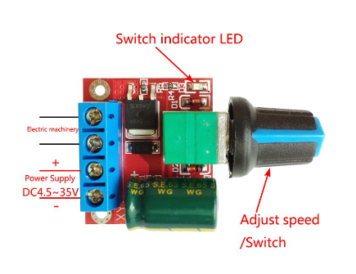

# **FIGURE 19. YELLOW GEAR MOTOR**



# **FIGURE 20. RC SERVO MOTOR TEST CIRCUIT**

* 1. **Test ARDUINO UNO R3**

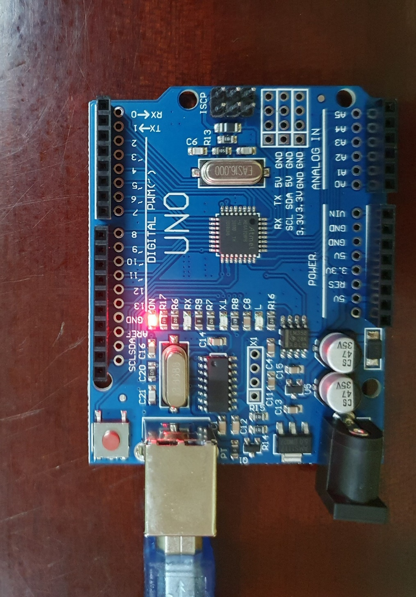

# **FIGURE 21. PLUG THE CIRCUIT BOARD INTO THE COMPUTER**

I use the sample code “Blink” in the Arduino IDE to test the circuit board.

First, we OPEN the ARDUINO IDE software.

Next, after the program interface appears, we choose FILE.

Then, we choose EXAMPLES.

After that, we will see a list of example that the program provide for us.

Then, we choose BASIC which is in the top of EXAMPLE.

Next, as you can see, there are many examples which have been done for you, and I think that to test my ARDUINO UNO R3 chip CH340G, I will choose a program that shows how the board works the easiest, it is “BLINK”.

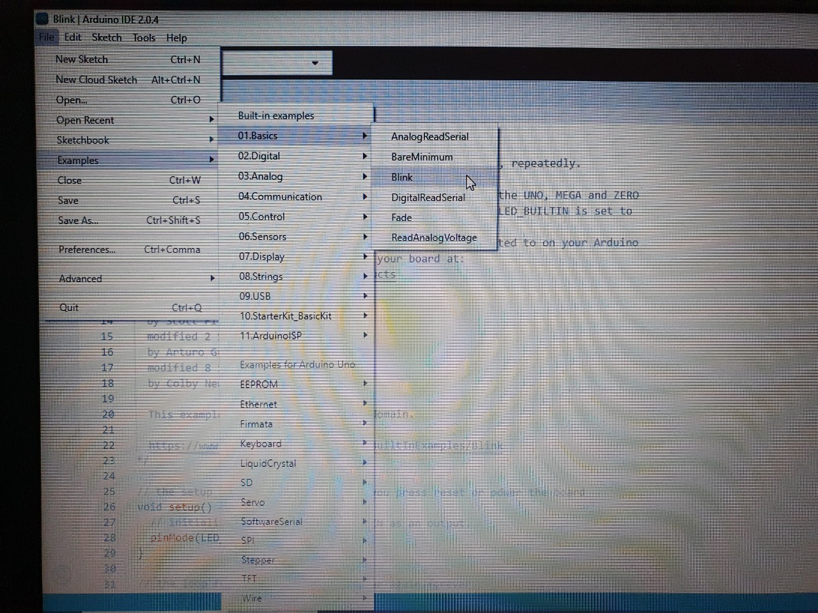

# **FIGURE 22. THE SAMPLE CODE “BLINK” IN ARDUINO IDE**

First, we OPEN the ARDUINO IDE software.

Next, after the program interface appears, we choose FILE.

Then, we choose EXAMPLES.

After that, we will see a list of example that the program provide for us.

Then, we choose BASIC which is in the top of EXAMPLE.

Finally, we choose BLINK.

After a series of actions above, the sample code for "BLINK" will appear on your computer screen.

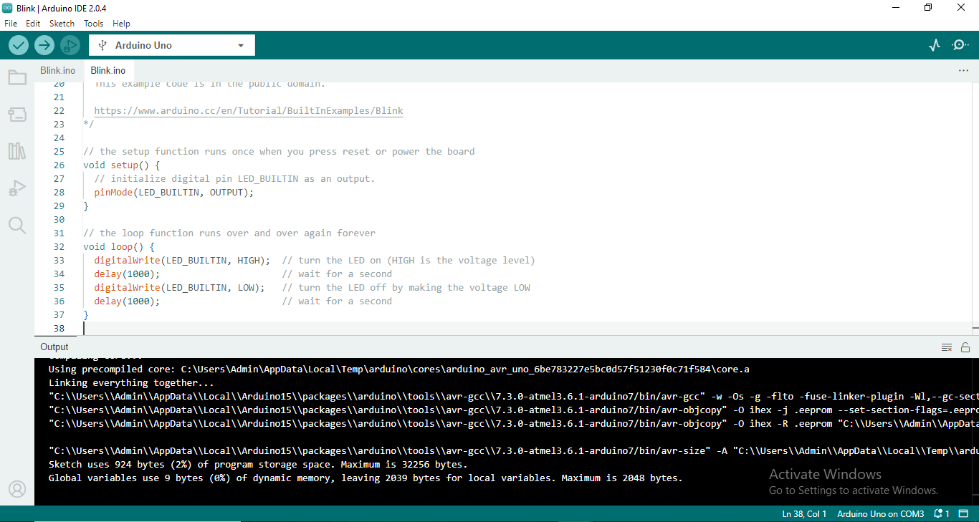

# **FIGURE 23. THE SAMPLE CODE “BLINK” CONNECT WITH ARDUINO PORT**

In this code, you can see in the void loop()

We have the line delay(1000), it means the led in arduino will delay one second.

First, digitalWrite(LED_BUILTIN, HIGH) the led will on in one second

Then digitalWrite(LED_BUILTIN, LOW) the led will off in one second.

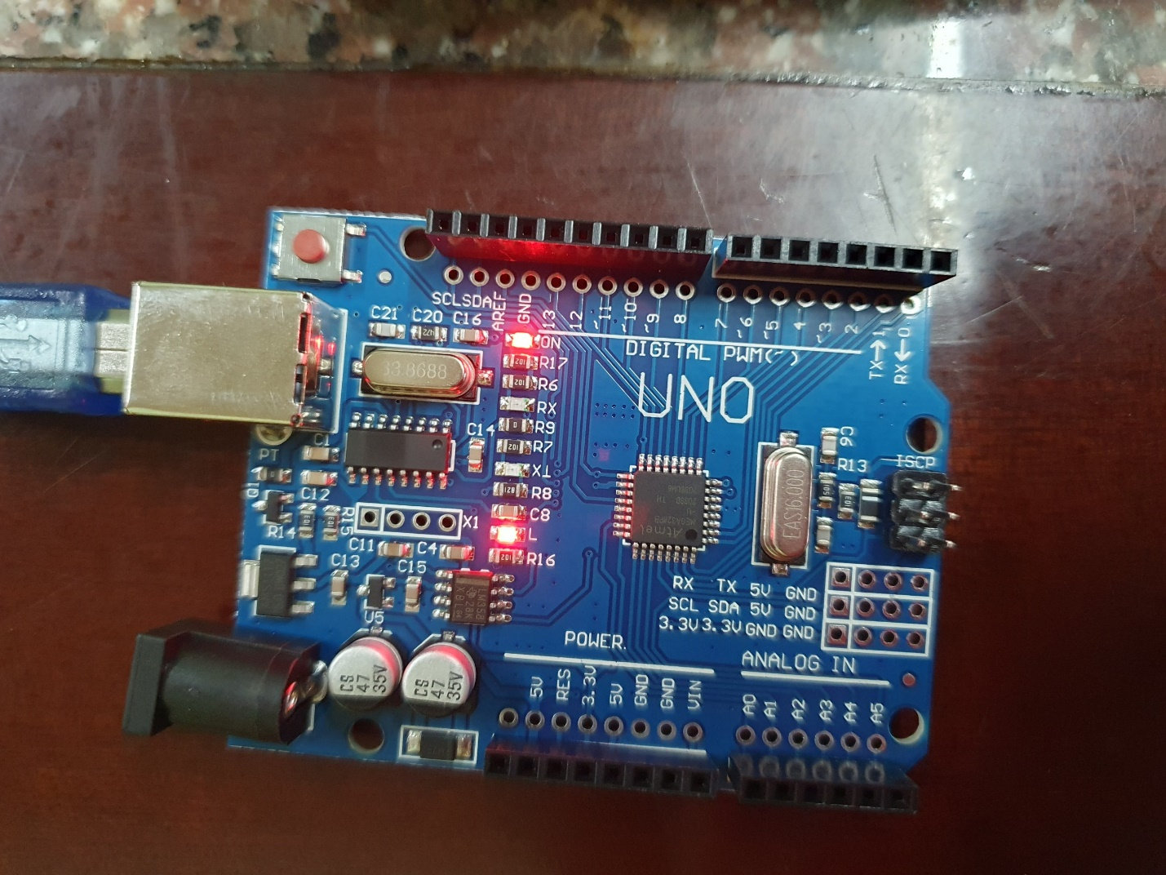

# **FIGURE 24. THE LED LIGHT OF ARDUINO BOARD IS TURN ON WHEN YOU UPLOAD THE CODE TO THE BOARD**

At first, if you want to see how the code “BLINK” works on your test board.

YOU MUST HAVE THE TEST BOARD FIRST – Arduino Uno R3 or Arduino Uno R3 chip CH340G

Then, you must buy it in a reputation shop, it has many prices, but do not try to find the cheapest price, you MUST find the place that sell the board with good quality.

Next, If the store does not provide a code loading cable, you must order an additional cable to be able to load the code from the software to the board.

Finally, we connect the board to your computer to see how this code work after you upload it.

* 1. **Test module HC-SR04**

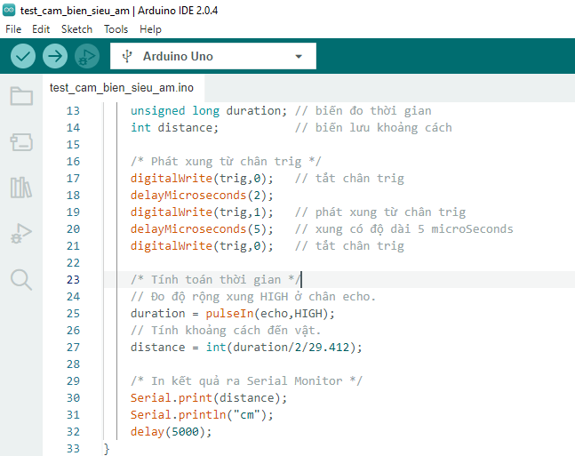

# **FIGURE 25. THE TEST CODE OF ULTRASONIC SENSOR**

First, we OPEN the ARDUINO IDE software.

Then, there are many example code on the internet, you can watch and follow that code.

About me, I follow the page which I have tag in the reference, then I write the code into the program.

So you can see, here is my code to test the Ultrasonic Sensor.

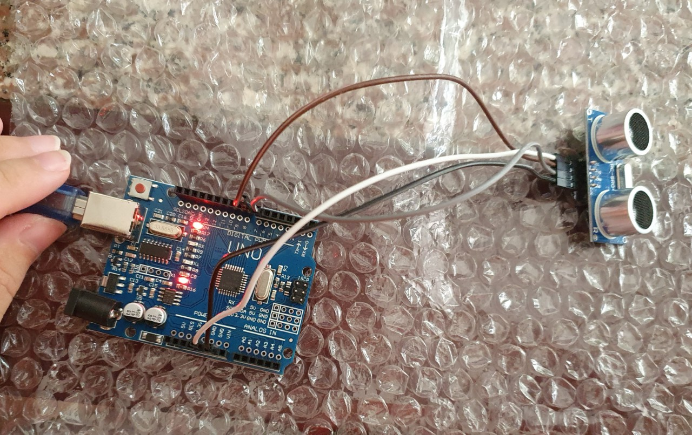

# **FIGURE 26. CONNECT THE ULTRASONIC SENSOR TO A ARDUINO BOARD**

Table of port connection:

|  |  |
| --- | --- |
| ULTRASONIC SENSOR | ARDUINO TEST BOARD |
| VCC | 5V |
| TRIG | 8 |
| ECHO | 6 |
| GND | GND |

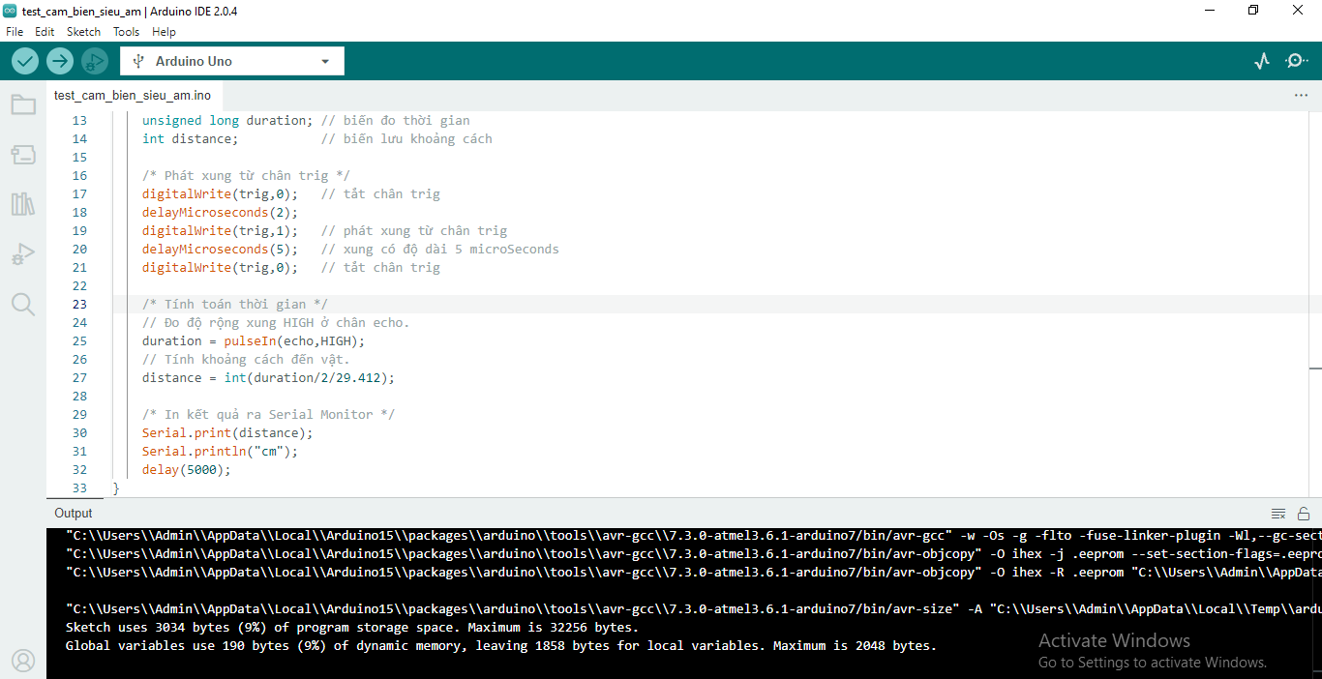

# **FIGURE 27. UPLOAD CODE TO ARDUINO BOARD**

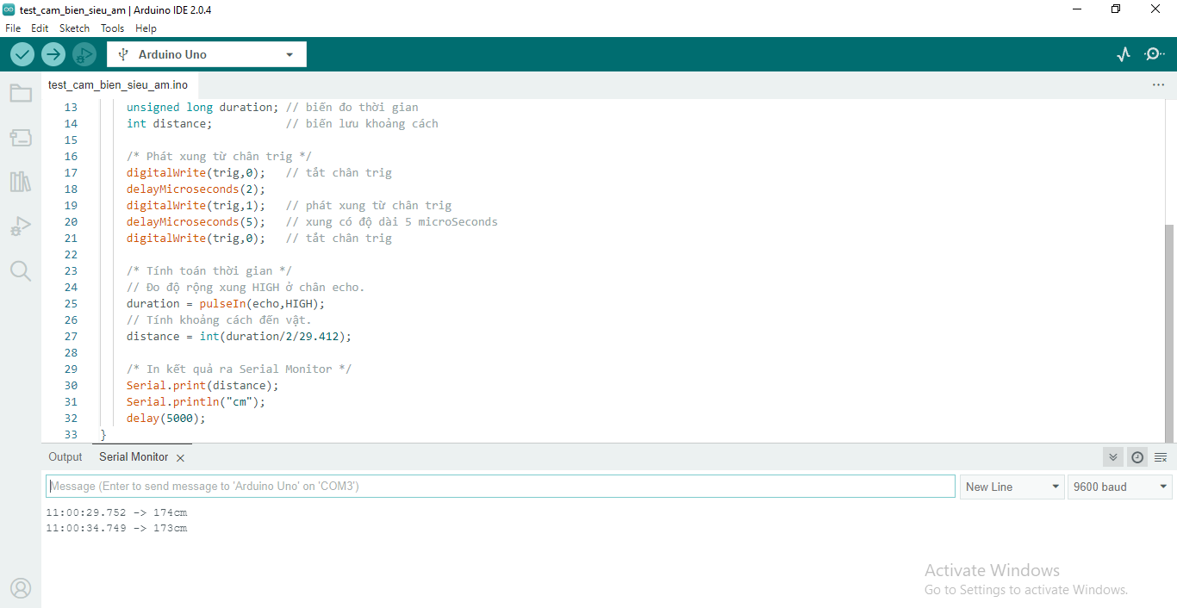

# **FIGURE 28. ULTRASOUND SENSOR MEASURES THE RANGE TO OBJECTIVES AND DISPLAYS ON SERIAL MONITOR OF ARDUINO IDE SOFTWARE**

* 1. **Test module LM393**

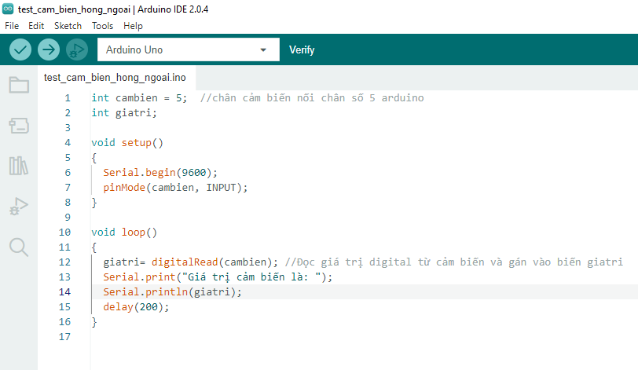

# **FIGURE 29. THE TEST CODE OF INFRARED SENSOR LM393**

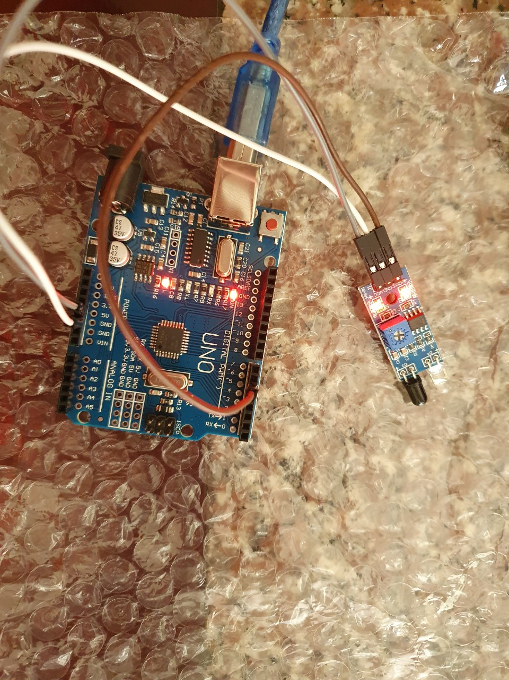

# **FIGURE 30. PLUG THE IR SENSOR TO ARDUINO BOARD**

Table of port connection:

|  |  |
| --- | --- |
| IR SENSOR | ARDUINO TEST BOARD |
| VCC | 5V |
| GND | GND |
| OUT | 5 |

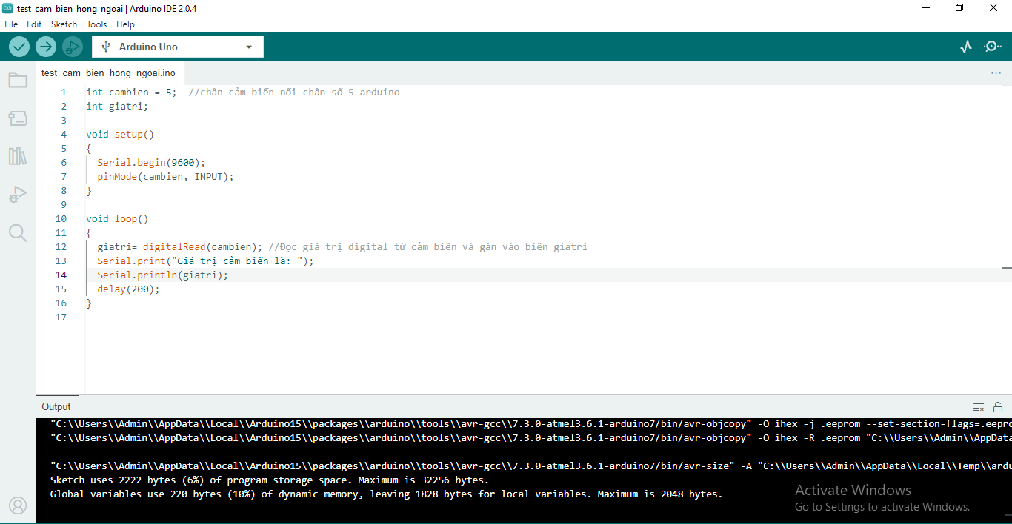

# **FIGURE 31. UPLOAD TEST CODE OF IR SENSOR TO ARDUINO SOFTWARE**

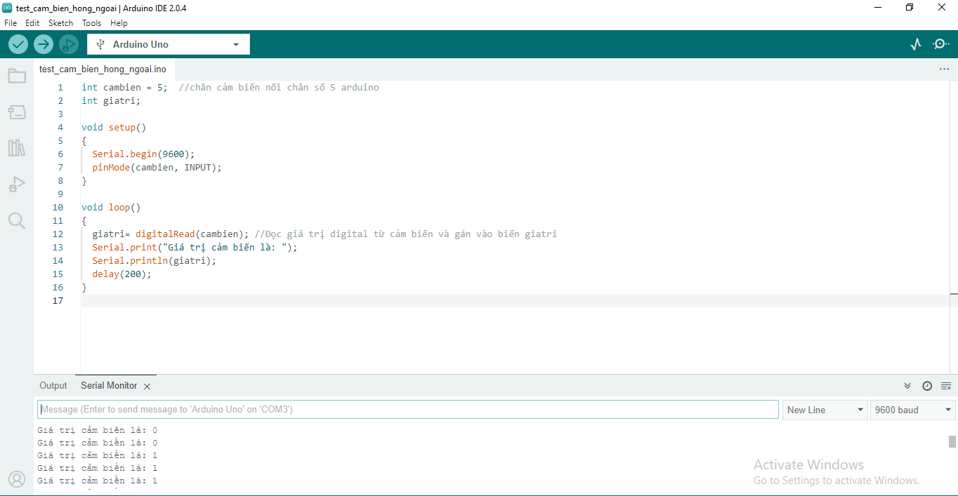

# **FIGURE 32. IR SENSOR MEASURES THE RANGE TO OBJECTIVES AND DISPLAYS ON SERIAL MONITOR OF ARDUINO IDE SOFTWARE**

When there is an obstacle in front, the sensor will record the number 0 and light up and vice versa, when there is no obstacle, the sensor will record the number 1.

**DESIGN & CODING**

1. **DESIGN**
   1. **Alternative diagram**

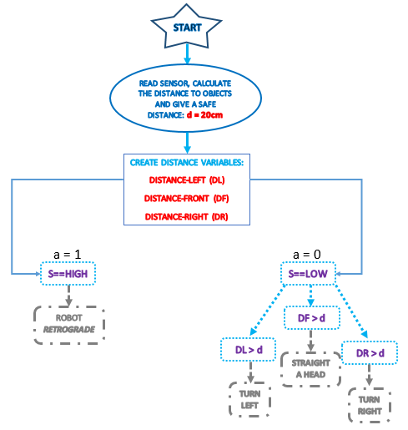

# **FIGURE 33. ALGORITHM DIAGRAM**

* 1. **Circuit assembly diagram**

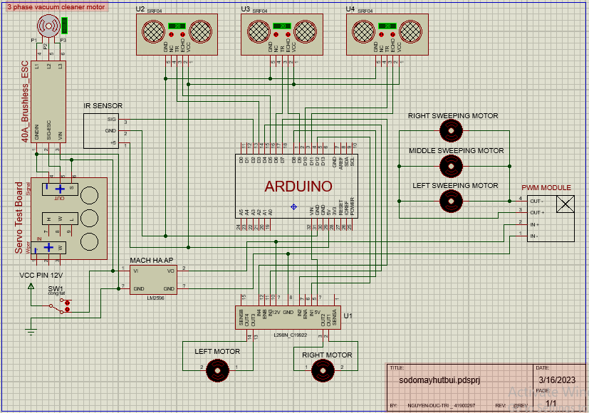................................

# **FIGURE 34. USING PROTEUS SOFTWARE TO SIMULATION**

1. 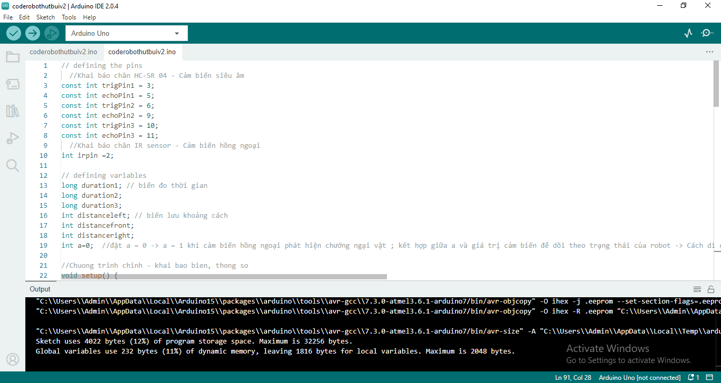**CODING**

# **FIGURE 35. SMART SWEEPING ROBOT CODE (1)**

First, we OPEN the ARDUINO IDE software.

Next, we choose FILE.

Then, we choose NEW SKETCH.

After that, a new window program is appear and you will write the code here.

After you finish the code, you choose FILE.

Next, you choose SAVE AS and then select the location where you want to save the file.

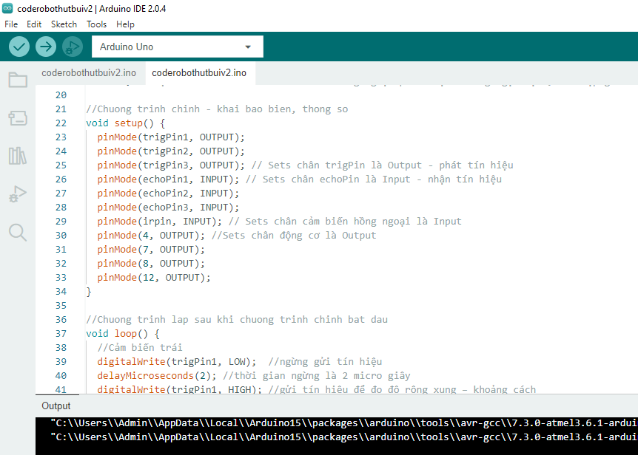

# **FIGURE 36. SMART SWEEPING ROBOT CODE (2)**

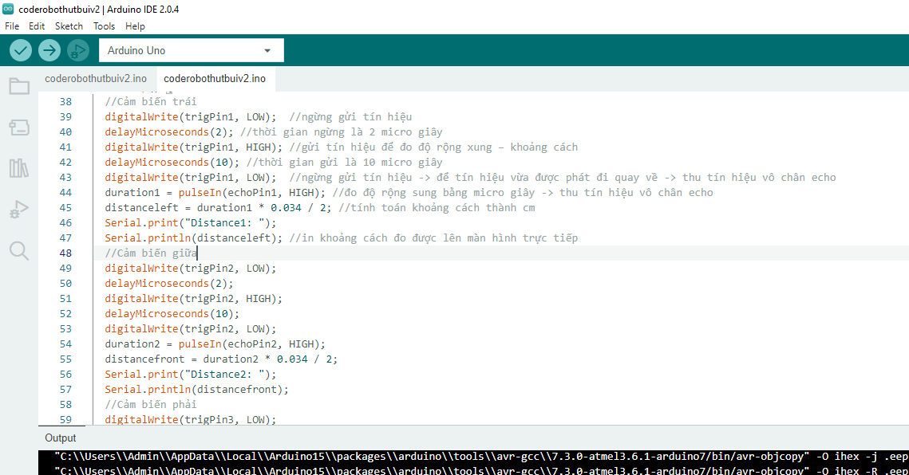

# **FIGURE 37. SMART SWEEPING ROBOT CODE (3)**

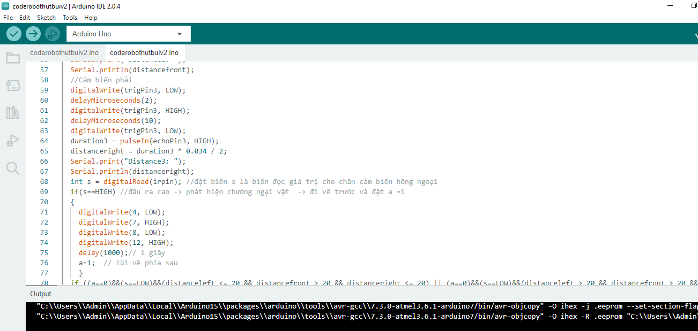

# **FIGURE 38. SMART SWEEPING ROBOT CODE (4)**

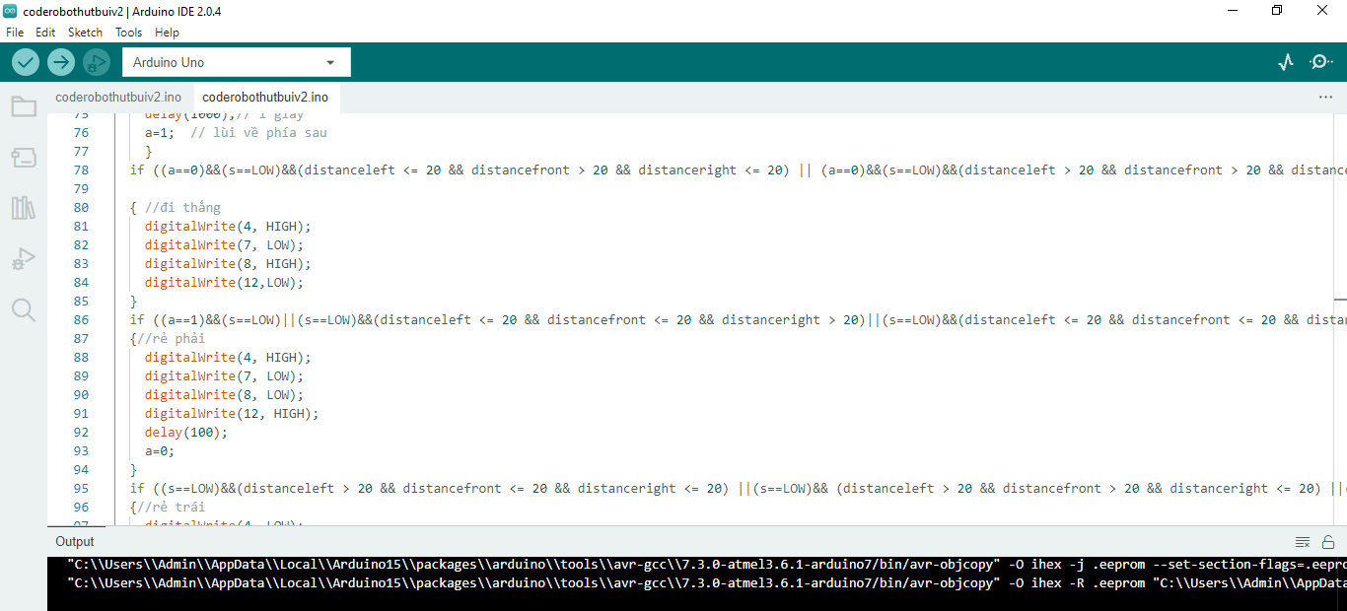

# **FIGURE 39. SMART SWEEPING ROBOT CODE (5)**

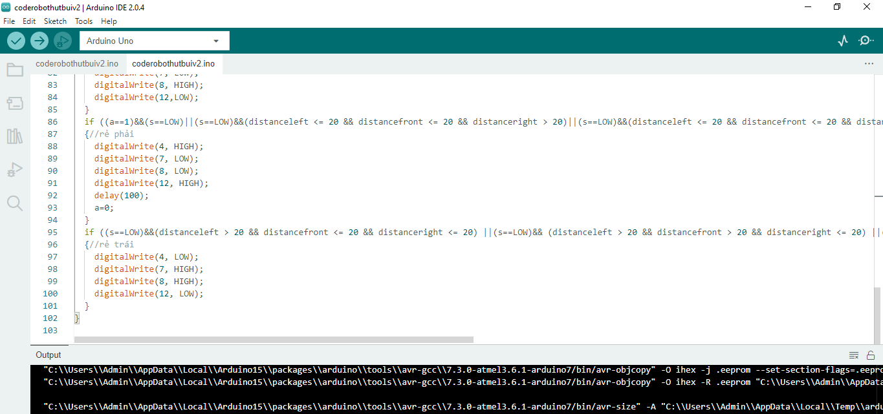

# **FIGURE 40. SMART SWEEPING ROBOT CODE (6)**

1. **SUPPLIES AND COMPONENTS**

|  |  |  |
| --- | --- | --- |
| STT | NAME OF COMPONENT | QUANTITY |
| 1 | Arduino Uno R3 chip CH340G | 1 |
| 2 | Ultrasonic Sensor HC-SR04 | 3 |
| 3 | IR Sensor  (Infrared obstacle sensor LM393) | 1 |
| 4 | Module L298N | 1 |
| 5 | Module DC LM2596 3A | 1 |
| 6 | Module DC PWM 5A, 3-35V | 1 |
| 7 | Module RC Servo | 1 |
| 8 | Module ESC 30A | 1 |
| 9 | Yellow gear motor | 4 |
| 10 | Motor Nidec BLDC | 1 |
| 11 | Pin Lipo 2S 2200mAh | 1 |
| 12 | Switch | 1 |

**TESTING AND EVALUATION**

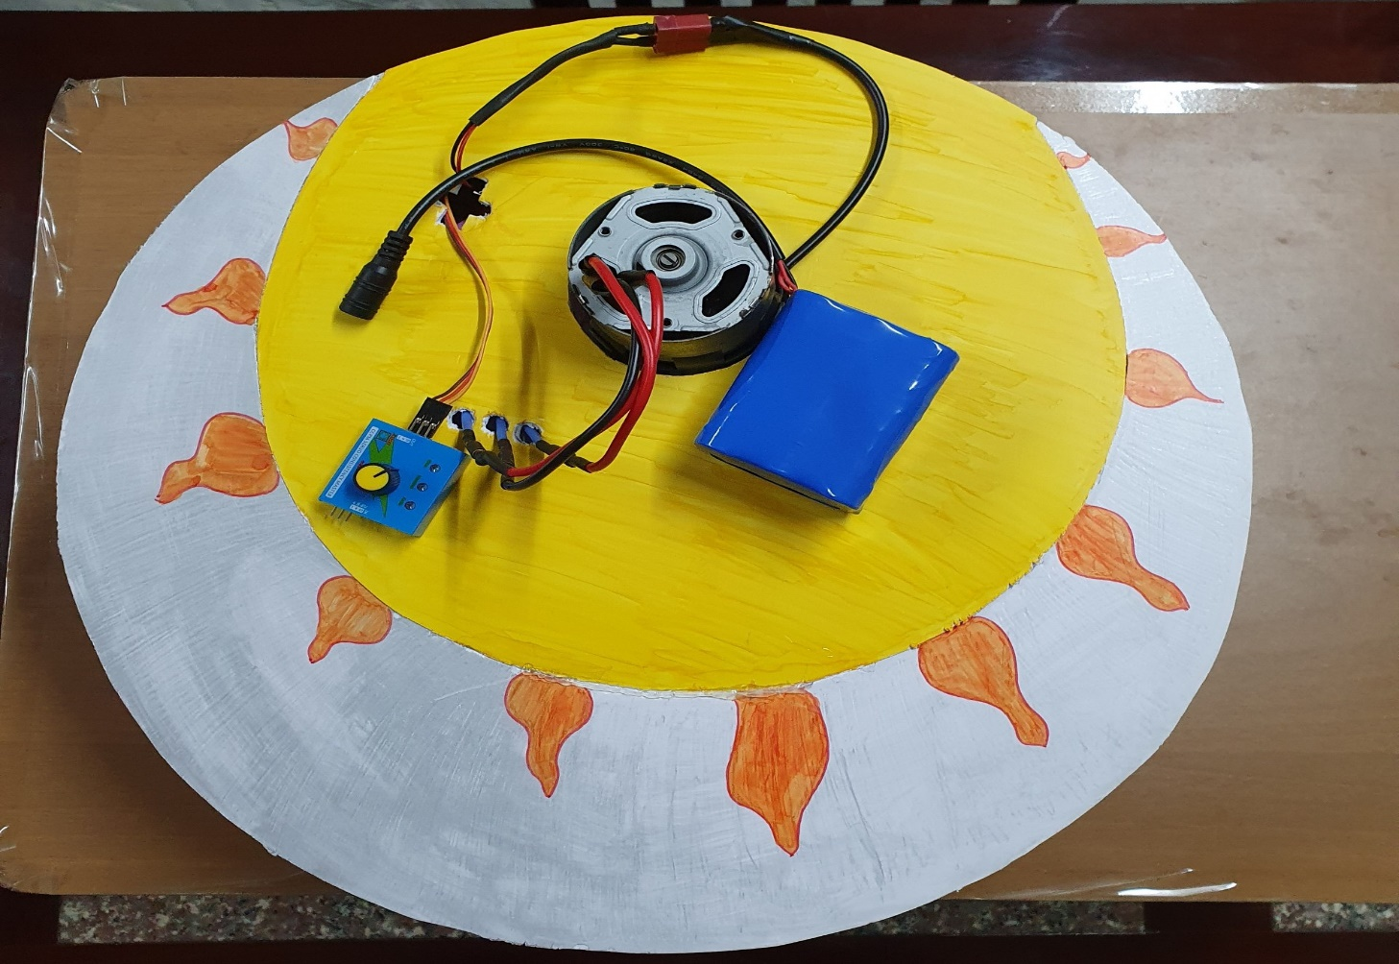

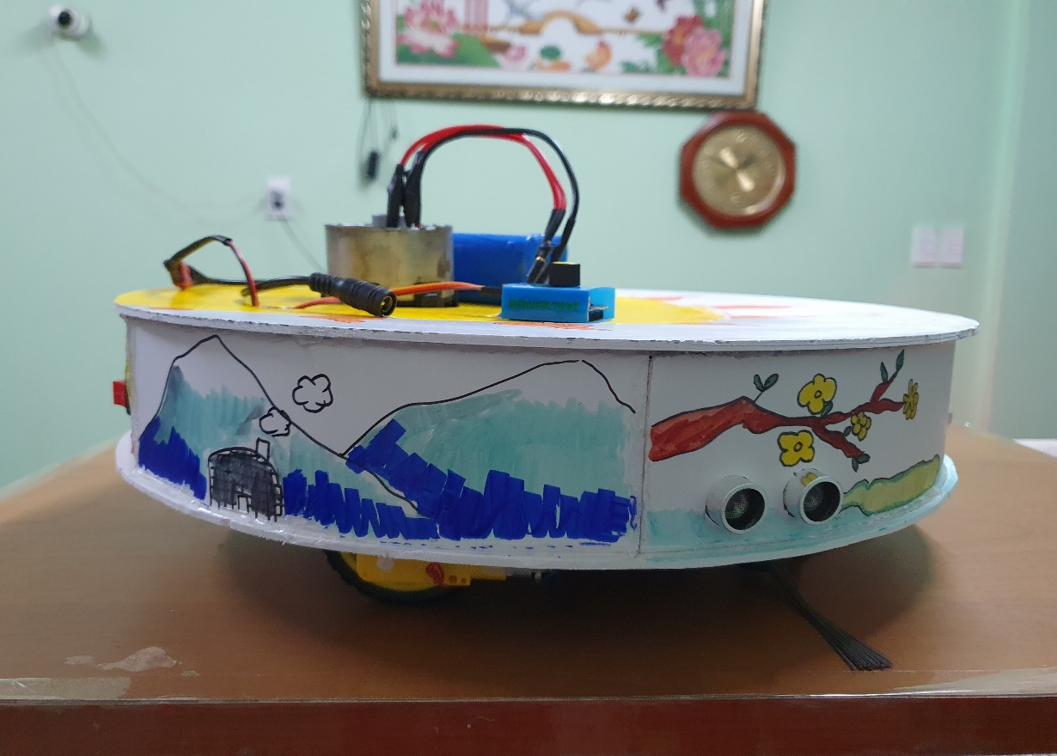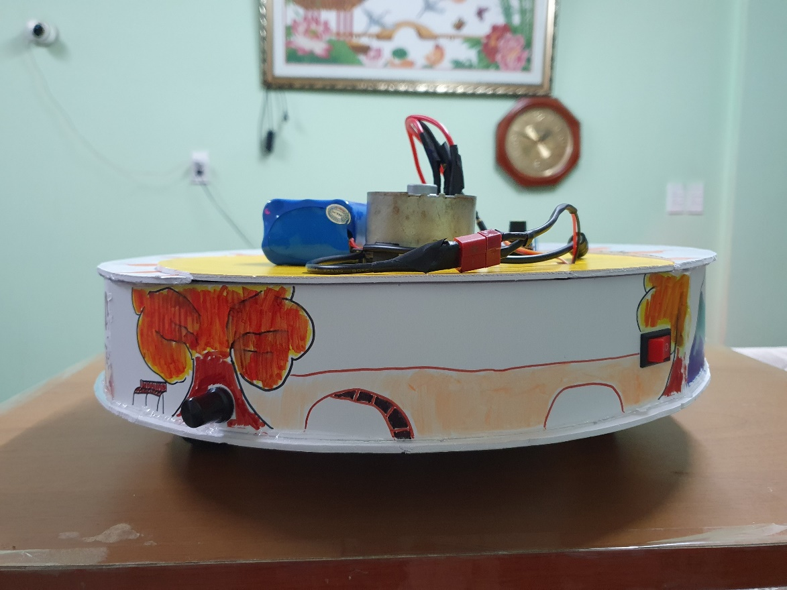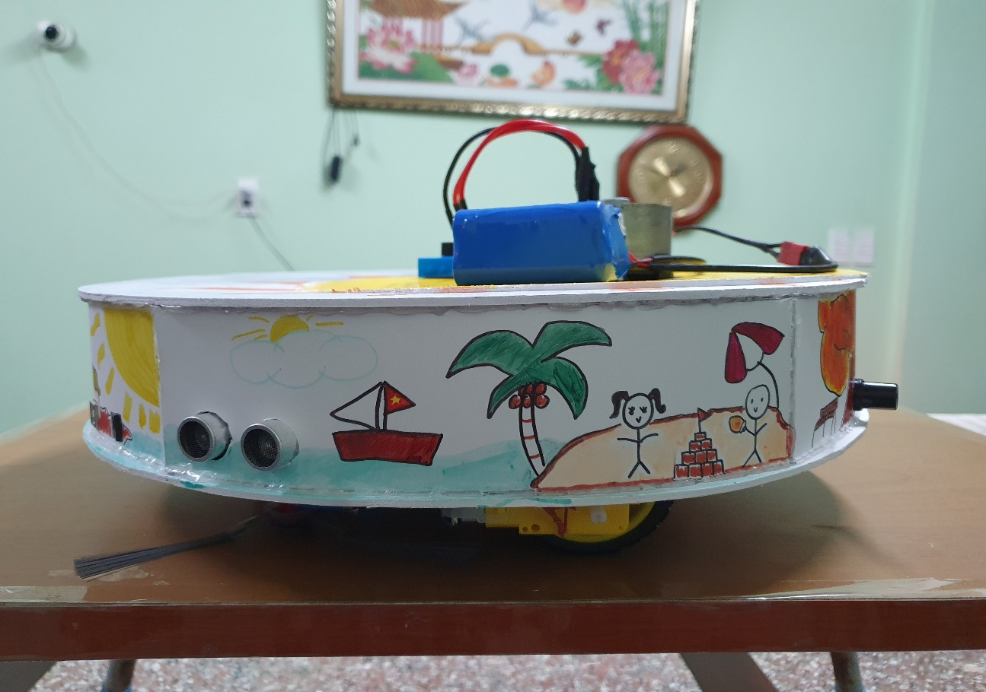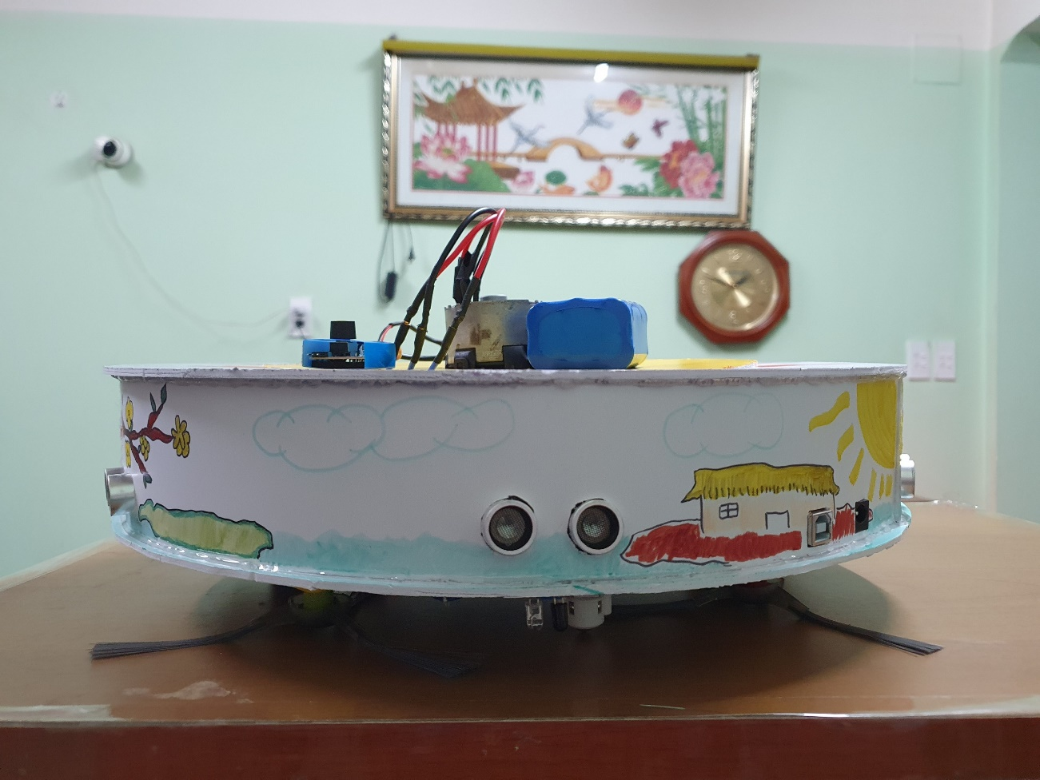

**REFERENT**

1. <https://forum.arduino.cc/t/power-button-for-obstacle-detecting-robot/963889>
2. <https://forum.arduino.cc/t/issues-with-ultrasonic-sensors-one-out-of-three-isnt-reading/636798>
3. <https://www.youtube.com/watch?v=F0LJusFMqL0>
4. <http://arduino.vn/bai-viet/42-arduino-uno-r3-la-gi>
5. [https://icdayroi.com/mach-giam-ap-dc-lm2596-3a#:~:text=tin%20s%E1%BA%A3n%20ph%E1%BA%A9m-,M%E1%BA%A1ch%20h%E1%BA%A1%20%C3%A1p%20DC%20LM2596S%203A%20nh%E1%BB%8F%20g%E1%BB%8Dn%20c%C3%B3%20kh%E1%BA%A3,motor%2C%20robot%2C...&text=H%C6%B0%E1%BB%9Bng%20d%E1%BA%ABn%20s%E1%BB%AD%20d%E1%BB%A5ng%3A%20Module,%C4%91%E1%BB%83%20ch%E1%BB%89nh%20%C3%A1p%20%C4%91%E1%BA%A7u%20ra](https://icdayroi.com/mach-giam-ap-dc-lm2596-3a#:~:text=tin%20s%E1%BA%A3n%20ph%E1%BA%A9m-,M%E1%BA%A1ch%20h%E1%BA%A1%20%C3%A1p%20DC%20LM2596S%203A%20nh%E1%BB%8F%20g%E1%BB%8Dn%20c%C3%B3%20kh%E1%BA%A3,motor%2C%20robot%2C...&text=H%C6%B0%E1%BB%9Bng%20d%E1%BA%ABn%20s%E1%BB%AD%20d%E1%BB%A5ng%3A%20Module,%C4%).
6. <https://huphaco.vn/cam-bien-sieu-am-hc-sr04/#:~:text=Nguy%C3%AAn%20l%C3%BD%20ho%E1%BA%A1t%20%C4%91%E1%BB%99ng%20c%E1%BA%A3m,ph%E1%BA%A3n%20x%E1%BA%A1%20%E1%BB%9F%20ch%C3%A2n%20n%C3%A0y>.
7. <http://arduino.vn/bai-viet/893-cach-dung-module-dieu-khien-dong-co-l298n-cau-h-de-dieu-khien-dong-co-dc>
8. <https://www.youtube.com/watch?v=WQhdtuRfap0&t=92s>
9. [Arduino | Cách sử dụng cảm biến hồng ngoại | Vật cản hồng ngoại - YouTube](https://www.youtube.com/watch?v=GEv9e1pXjV4)
10. <https://linhkiendientu.com.vn/sanpham/mdl143-module-dieu-khie%CC%89n-do%CC%A3ng-co-pwm-5a-3-35v-chiet-ap-cong-tac/>
11. <https://chotroihn.vn/module-dieu-khien-dong-co-khong-choi-than-30a-k1h11-3-34g>
12. <https://mualinhkien.vn/mach-test-dong-co-rc-servo>

**APPENDIX A. PROGRAMMING CODE**

1. **Defining the pins**

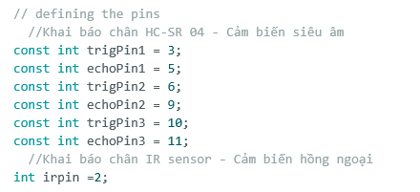

1. **Defining the variables**

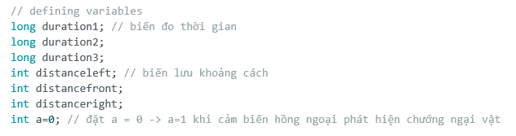

1. **Setup**

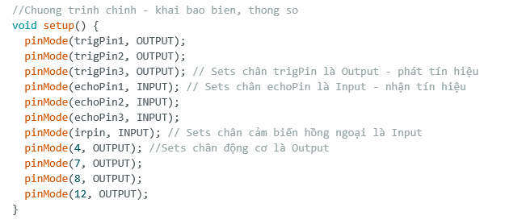

1. **Loop**

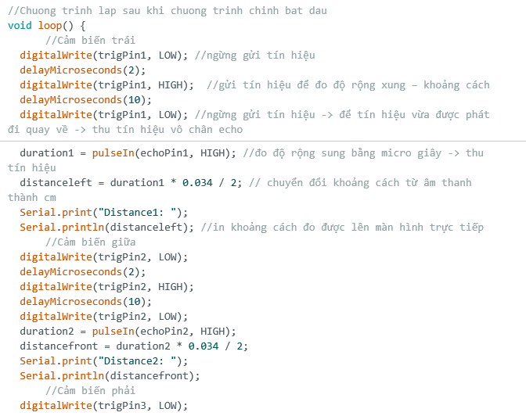

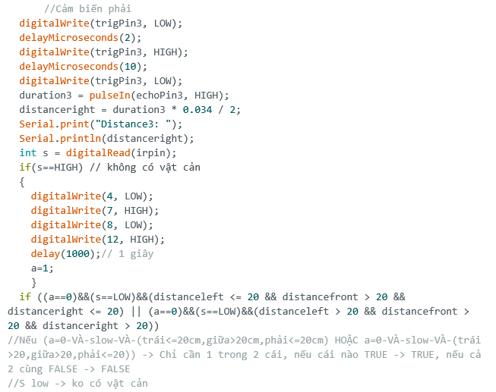

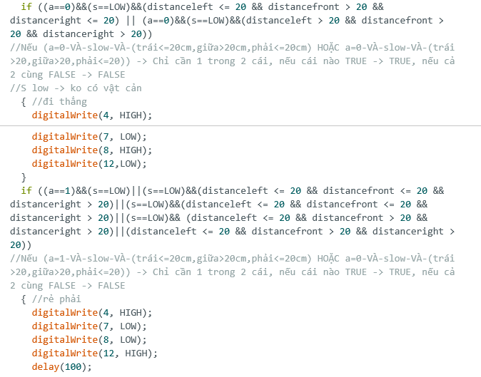

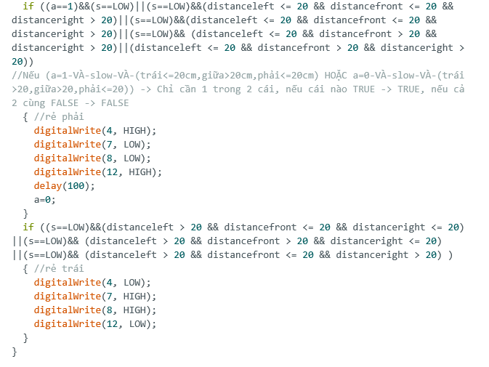

**SLIDE POWERPOINT**

